2nd HTTP Wireshark Capture … using HTTP2 filter: A deep-dive interpretation
This capture shows HTTP-related security traffic, but not normal HTTP pages. It shows Certificate Revocation List (CRL) retrieval — a critical part of HTTPS trust….or….
This capture shows an HTTP download of a Certificate Revocation List (CRL), which is part of the TLS certificate validation process. When a device connects to a secure HTTPS site, it may retrieve a CRL from the certificate’s distribution point to verify that the certificate has not been revoked. Wireshark decodes this traffic as PKIX-CM and displays the CRL structure, including serial numbers and signature information. This is normal background security traffic and demonstrates how HTTP is used to support TLS trust mechanisms.
Breaking this down let’s define: TCP, TLS, and HTTP inside Wireshark.
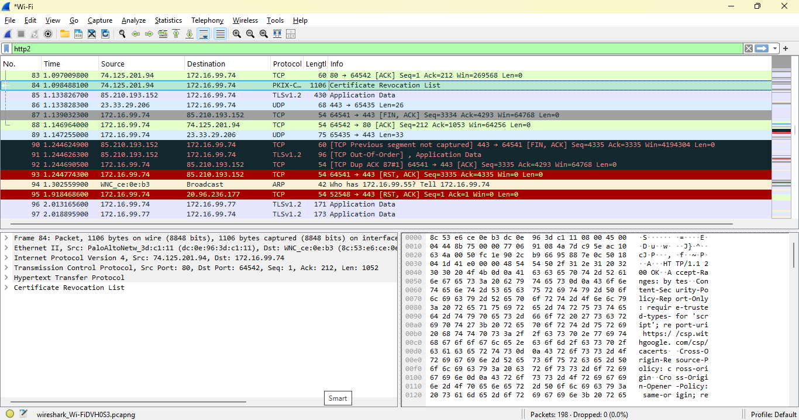
The takeaway:
This capture shows the system downloading a Certificate Revocation List (CRL) over HTTP, which is part of the TLS certificate validation process. CRLs are used to check whether a certificate has been revoked. This is normal, security-critical background traffic.
The screenshot shows:
- Protocol: PKIX-CM (Public Key Infrastructure — Certificate Management)
- Message: Certificate Revocation List
- Transport: HTTP over TCP
- Purpose: Validate TLS certificates
- Context: Part of HTTPS security, not normal web browsing
This is not “HTTP content” like webpages — it’s HTTP used for security metadata.

This traffic appears because:
When your browser or OS connects to a secure site (HTTPS), it must verify:
- Is the certificate valid?
- Is the certificate trusted?
- Has the certificate been revoked?
To answer #3, your system may:
- Download a CRL (Certificate Revocation List)
- Perform an OCSP check (Online Certificate Status Protocol)
- Use OCSP stapling
- Use CRL distribution points embedded in the certificate
This capture shows the CRL distribution point method.
Define: CRL
A Certificate Revocation List is a file published by a Certificate Authority (CA) that contains:
- Serial numbers of revoked certificates
- Reasons for revocation
- Validity period
- Signature from the CA
This system downloads this file to ensure:
“The certificate I’m about to trust has NOT been revoked.”
This is essential for:
- Preventing man-in-the-middle (MITM) attacks
- Detecting compromised certificates
- Maintaining HTTPS trust
Wireshark shows CRL traffic by …
Wireshark decodes CRL downloads as:
- PKIX-CM
- Certificate Revocation List
- HTTP GET
- HTTP 200 OK
- CRL payload
Layers that appear:
- Ethernet
- IPv4
- TCP
- HTTP
- PKIX-CM
- CRL
This is exactly what my screenshot shows.
Why this is NOT “normal HTTP”
Normal HTTP traffic contains:
- URLs
- Headers
- HTML
- JSON (JavaScript Object Notation)
- Images
- API calls
My capture contains:
- Security metadata
- Certificate trust information
- Revocation lists
This is part of the TLS handshake ecosystem, not web browsing.
How does this fit into TCP vs TLS vs HTTP?
Here’s the clean hierarchy:
1️⃣ TCP
The transport layer. Handles:
- Ports
- Sequence numbers
- ACKs
- Retransmissions
- Flow control
The capture shows TCP delivering the CRL file.
2️⃣ HTTP
The application protocol. Used here to download the CRL file.
Your capture shows:
- HTTP GET
- HTTP 200 OK
- CRL payload
3️⃣ TLS
The encryption layer for HTTPS. CRL downloads happen outside TLS because:
- The system must validate the certificate before trusting TLS
- CRLs are public
- No need to encrypt them
So this traffic is:
HTTP used for TLS certificate validation.
Why this matters for SOC / cybersecurity
CRL traffic helps analysts detect:
- Certificate spoofing
- MITM attempts
- Malware using forged certificates
- TLS failures
- Revocation anomalies
If a system:
- Repeatedly fails CRL downloads
- Contacts unknown CRL servers
- Downloads unusually large CRLs
- Uses non-standard revocation endpoints
…it can indicate compromise.
This capture shows normal behavior.

